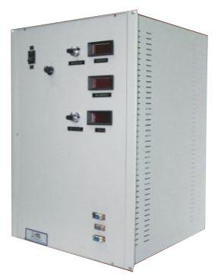
This series of precision regulated power supplies consist of a high voltage unit for electron gun and a filament supply, either floating on high voltage or at ground potential, both house in a single rack These are designed specifically for scanning Electron Microscope that require high stability and low ripple noise.
REGULATED HIGH VOLTAGE POWER SUPPLY FOR
SCANNING ELECTRON MICROSCOPE
Up to 120kV, 150W

Features:
- Precision Regulated
- Low Ripple
- High Stability
- 19” Rack Mountable
- OEM Customization Available

Technical Specifications
PARAMETER | SPECIFICATION
Input Voltage | 230V ±10% A C, 50Hz, single phase
Front Panel | AC Power ON/OFF switch with indication  HV ON/OFF switch with indication  3½ dig it meters for display of output high voltage & current, filament voltage  10-turn potentiometers for control of high voltage and current, filament voltage
Back Panel | Socket for mains input with 250V, 10A/20A 3 conductor power cord of 1.5 meters  Fuse holder with fuse  Terminal for HV output with 10ft of detachable high voltage cable  Terminal for filament output  Stud for grounding the unit  Remote interface connector*
Topology | High frequency resonant / PWM-controlled switch mode
Switching Device | IGBT
Cabinet | 2U to 5U 19” rack mountable, powder coated
HIGH VO LTAGE POWER SUPPLY
Output Voltage Range* | Upto 120kV DC
Output Power Range* | Upto 150W
Polarity* | Negative
Line Regulation | Better than 0.005% for 10% variation in input voltage
Load Regulation | Better than 0.005% for 0 to 100% load variation
Ripple | 0.05% at full rating
Stability | Better than 0.005%/hour after 1 hour warm up
Regulation Mode* | Constant voltage
Voltage & Current Control* | Local: By 10-turn potentiometers on the front panel  Remote: 0 to 10V DC signals for voltage & current control
Protections* | Against over load, over current, short-circuit and arc
Remote Controls & Signals through Pluggable Connector / D-Connector | 10V DC reference  10V DC HV enable signal  0 to 10V DC signal for voltage & current control  0 to 10V DC signal for voltage & current monitoring
FILAMENT POWER SUPPLY
Output Voltage Range* | 10V DC typical
Output Power Range* | 4A typical
Polarity* | Floating on high voltage output / Positive
Line Regulation | 1%
Voltage Control* | Local: By 10-turn potentiometers on the front panel  Remote: 0 to 10V DC signal for voltage control
Remote Controls & Signals through Pluggable Connector / D-Connector | 10V DC reference  0 to 10V DC signal for voltage & current monitoring  0 to 10V DC signals for voltage control

*Optional. To be specified by the user only as per application’s requirement.

For any queries or customization requests contact us at info@ionics.co.in
For product line information visit us at www.ionics.co.in

